1. Trung tâm truyền số liệu (VDC) chuẩn bị tổ chức gói thầu ‘VNN Email Message system’: Cung cấp các thiết bị và phần mềm đáp ứng cho nhu cầu sử dụng của 500.000 khách hàng, với dung lượng mailbox loại lớn là 100 MB/mailbox, loại vừa là 20MB/mailbox. Hãy lên WBS cho biết có những CV gì, cần bao nhiêu người làm, thời gian bao lâu, chi phí bao nhiêu?

**WBS for the project:**

1. Project Management

1.1 Project Planning

1.2 Project Execution

2. Requirements Gathering

2.1 Define Project Scope

2.2 Requirements Elicitation

2.3 Requirements Validation

3. Conceptual Design

3.1 System Architecture Design

3.2 Database Design

3.3 User Interface Design

4. Detailed Design

4.1 Software Design

4.2 Hardware Design

4.3 Network Design

5. Development

5.1 Software Development

5.2 Hardware Development

5.3 Integration and Testing

6. Deployment

6.1 Installation and Configuration

6.2 User Training

7. Maintenance and Support

8. Quality Management

8.1 Quality Planning

8.2 Quality Assurance

8.3 Quality Control

9. Risk Management

9.1 Risk Identification

9.2 Risk Analysis

9.3 Risk Response Planning

Cost estimation:

* Project Management: we need a project manager, a project planner, a project controller, and a project closure specialist. This will take approximately 12 months to complete. The cost for this phase is estimated to be around $100,000.
* Requirements Gathering: we need a requirements analyst and a requirements manager. This phase will take approximately 2 months to complete. The cost for this phase is estimated to be around $50,000.
* Conceptual Design: we need a system architect, a database designer, and a user interface designer. This phase will take approximately 3 months to complete. The cost for this phase is estimated to be around $75,000.
* Detailed Design: we need a software designer, a hardware designer, and a network designer. This phase will take approximately 4 months to complete. The cost for this phase is estimated to be around $100,000.
* Development: we need software developers, hardware developers, and testers. This phase will take approximately 9 months to complete. The cost for this phase is estimated to be around $300,000.
* Deployment: we need installers and trainers. This phase will take approximately 2 months to complete. The cost for this phase is estimated to be around $25,000.
* Maintenance and Support: we need a maintenance team and a support team. This will be an ongoing process with an estimated cost of $50,000 per year.
* Contract and Procurement Management: we need a procurement specialist and a contract manager. This will take approximately 3 months to complete. The cost for this phase is estimated to be around $25,000.
* Quality Management: we need a quality planner, a quality assurance specialist, and a quality control specialist. This will be an ongoing process with an estimated cost of $50,000 per year.
* Risk Management: we need a risk manager and a risk analyst. This will be an ongoing process with an estimated cost of $30,000 per year.

2. Xây dựng tiệm net với phòng rộng 60m2 (hiện chưa có thiết bị, vật dụng). Yêu cầu cung cấp mọi thiết bị kể cả 1 server, 15 máy clients. Hãy lên WBS cho biết có những CV gì, cần bao nhiêu người làm, thời gian bao lâu, chi phí bao nhiêu?

**WBS for the project:**

1. Project Management

1.1 Project Planning

1.2 Project Execution

2. Requirements Gathering

2.1 Define Project Scope

2.2 Requirements Elicitation

2.3 Requirements Validation

3. Conceptual Design

3.1 System Architecture Design

3.2 Database Design

3.3 User Interface Design

4. Detailed Design

4.1 Software Design

4.2 Hardware Design

4.3 Network Design

5. Development

5.1 Software Development

5.2 Hardware Development

5.3 Integration and Testing

6. Deployment

6.1 Installation and Configuration

6.2 User Training

7. Maintenance and Support

8. Quality Management

8.1 Quality Planning

8.2 Quality Assurance

8.3 Quality Control

9. Risk Management

9.1 Risk Identification

9.2 Risk Analysis

9.3 Risk Response Planning

Cost estimation:

* Project Management: we need a project manager, a project planner, a project controller, and a project closure specialist. This will take approximately 6 months to complete. The cost for this phase is estimated to be around $50,000.
* For Requirements Gathering: we need a requirements analyst and a requirements manager. This phase will take approximately 1 month to complete. The cost for this phase is estimated to be around $10,000.
* For Conceptual Design: we need a business analyst, a system architect, a network designer, a database designer, and a user interface designer. This phase will take approximately 2 months to complete. The cost for this phase is estimated to be around $50,000.
* For Detailed Design: we need a software designer, a hardware designer, and a security designer. This phase will take approximately 2 months to complete. The cost for this phase is estimated to be around $30,000.
* For Development: we need a server configuration specialist, a client configuration specialist, a database developer, a website developer, and testers. This phase will take approximately 9 months to complete. The cost for this phase is estimated to be around $300,000.
* For Deployment: we need installers and trainers. This phase will take approximately 1 month to complete. The cost for this phase is estimated to be around $15,000.
* For Maintenance and Support: we need a maintenance team and a support team. This will be an ongoing process with an estimated cost of $30,000 per year.
* For Contract and Procurement Management: we need a procurement specialist and a contract manager. This will take approximately 2 months to complete. The cost for this phase is estimated to be around $20,000.
* For Quality Management: we need a quality planner, a quality assurance specialist, and a quality control specialist. This will be an ongoing process with an estimated cost of $30,000 per year.
* For Risk Management: we need a risk manager and a risk analyst. This will be an ongoing process with an estimated cost of $20,000 per year.

Based on the above estimates, the total cost of the net shop project would be approximately $535,000 and it would take around 12 months to complete.

3. Tính nỗ lực thực hiện công việc theo giờ (h) (Work),thời gian hoàn thành công việc(Duration), đơn vị nhân lực thực hiện (Units). Ta có công thức sau:

* Work = Duration * Units: ngày (1d)= 8h, 1 người làm fulltime 100%
* Duration = Work/Units
* Units = Work/ Duration

Ta có thể cố định theo cách sau: fixed Work, fixed Duration, fixed Units khi dự án không thể điều chỉnh thời gian, chi phí, nhân sự

Base on task 1, we have the following gant chart: <https://drive.google.com/file/d/1NJtynwRxL1Q_XgBYlzjXBWMcaSQN2SVK/view?usp=sharing>

1. Dự án có 500% Units, hoàn thành trong thời gian là 4d, hỏi nỗ lực thực hiện dự án trong bao nhiêu h.

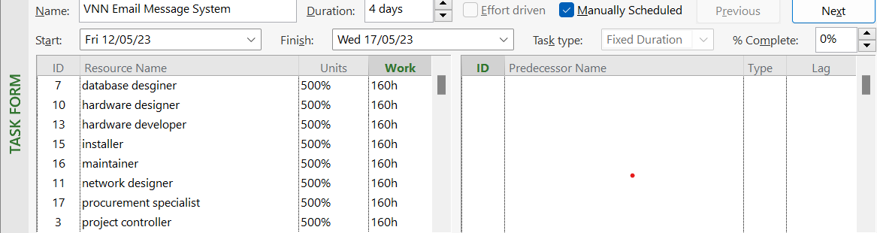

The effort is 160h

2. Dự án có 250% units, hoàn thành trong 7d, hỏi nỗ lực thực hiện dự án trong bao nhiêu h.

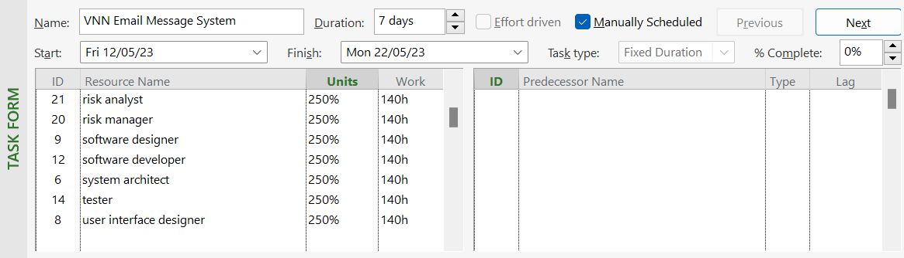

The effort is 140h

3. Dự án có 200% Units, hoàn thành trong 2d, hỏi nỗ lực thực hiện dự án trong bao nhiêu h.

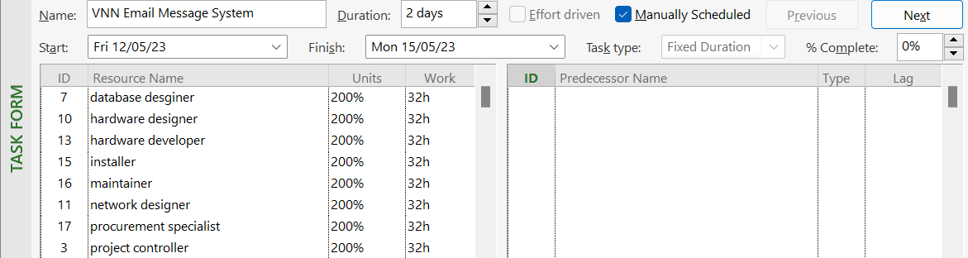

The effort is 32h

4. Nếu cố định fixed duration, ngày làm việc 8h, nỗ lực thực hiện trong 256h trong 2d, hỏi bao nhiêu Units để hoàn thành dự án. 5. Nếu cố định fixed Work, với 3 nhân lực (resource), nỗ lực hoàn thành trong 40h, hỏi phải hoàn thành trong thời gian bao lâu (duration).